STUDENT SATISFACTION SURVEY REPOT 2018-2019
- Course content
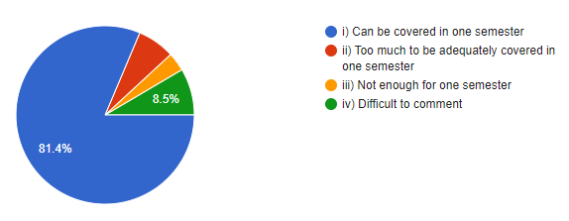
2 Recommended regarding material was
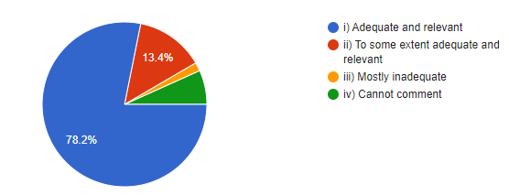
3 Teacher Communication Skill
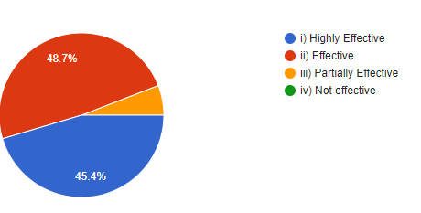
4 .Use of Teaching aids
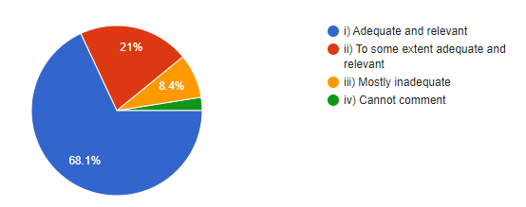
5. Class tests / mid- semester tests were conducted
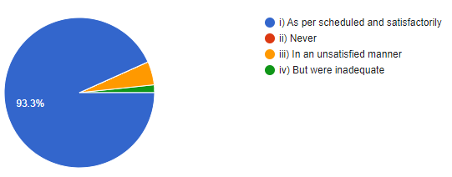

6. Fairness of the internal evaluation process by teachers
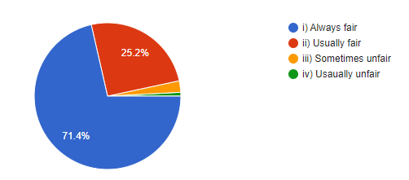
7. Was the performance in assignments discussed with you
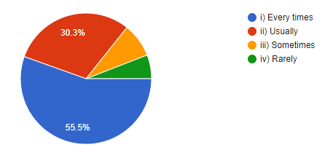
8. The institution provides multiple opportunities to learn and grow
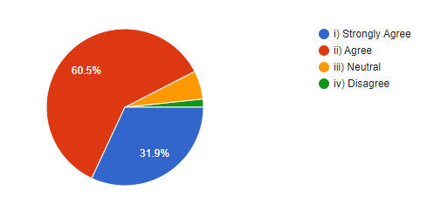
9. The teacher illustrate the concepts through examples and application
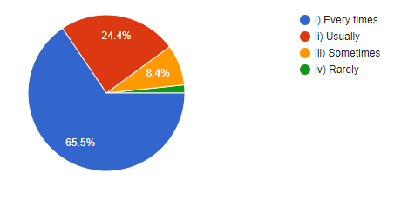

10. Teachers are able to identify your weaknesses and help you to overcome them
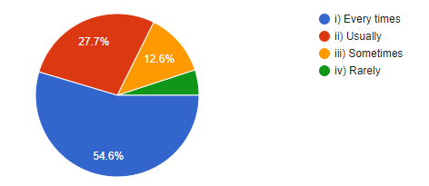

11. Internet facilities available on the campus
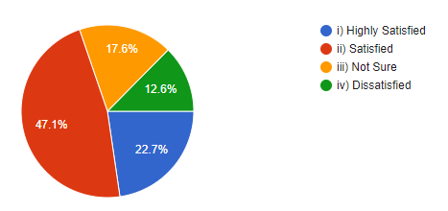
12. Common room in the college building
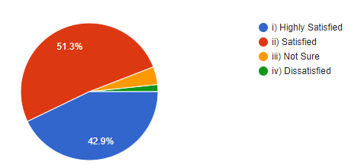
13. Maintance and hygiene of toilet/washroom
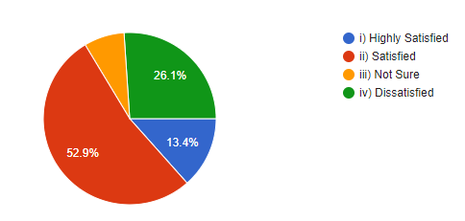
14. Availability of clean drinking water
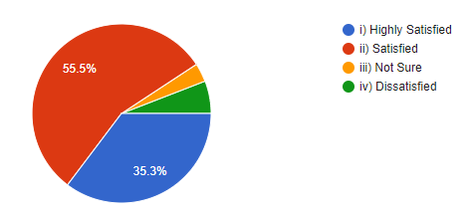
15. Equipment in the laboratories/ Music rooms
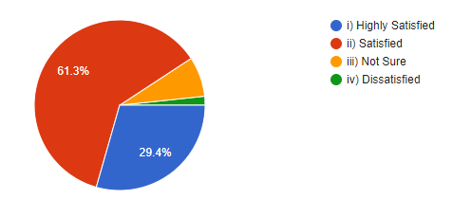

16. Canteen facilities
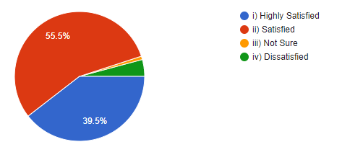
17. Parking facilities
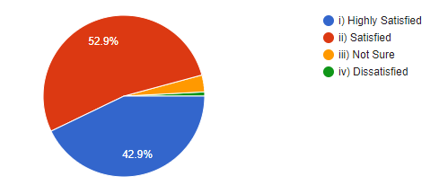
18. Playground
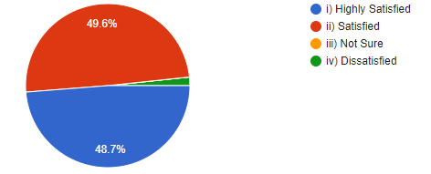
19. NCC/NSS Room
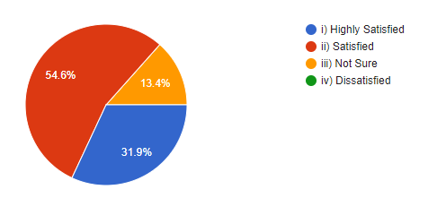

20. Hostel and other accommodation facilities
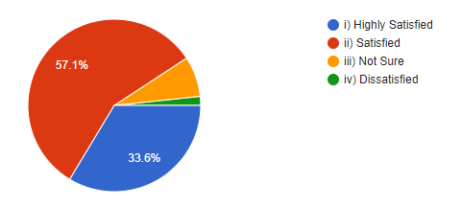
21. Give three observation/ Suggestion to improve the overall teaching-learning experiences in your institution
- Positive reinforcement.
- A flexibility in teaching
- Try to reach every student and ask their doubts, use better graphics and visual media
- Need time and practice other activities like sports and culture
- Improvement of toilet hygiene
- Internet facilities should be better.
- all good
- Awesome

