STUDENT SATISFACTION SURVEY REPORT 2017-2018
- Course content
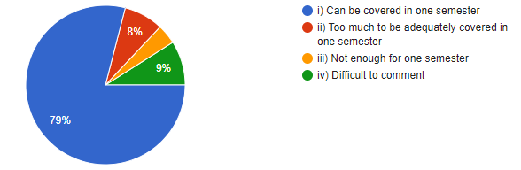
- Recommended regarding material was
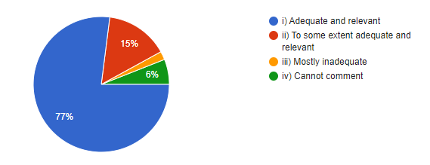
3 Teacher Communication Skill
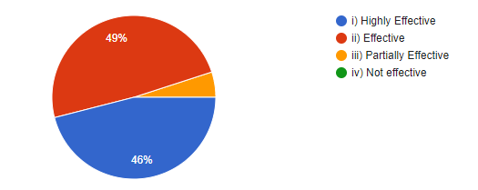
4 .Use of Teaching aids
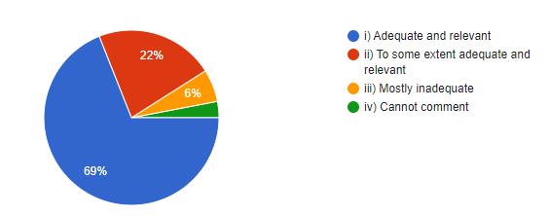
5. Class tests / mid- semester tests were conducted
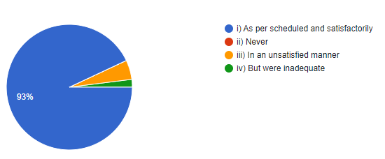
6. Fairness of the internal evaluation process by teachers
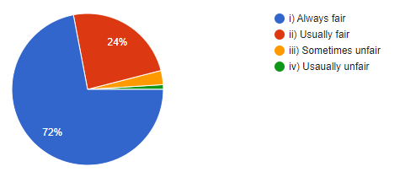
7. Was the performance in assignments discussed with you
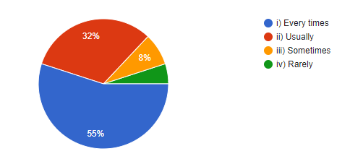
8. The institution provides multiple opportunities to learn and grow
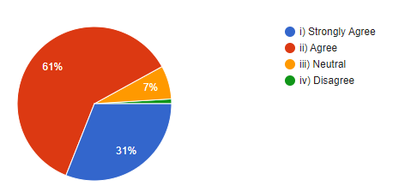
9. The teacher illustrate the concepts through examples and application
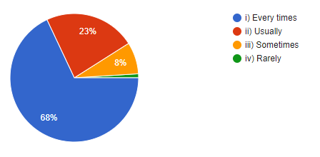
10. Teachers are able to identify your weaknesses and help you to overcome them
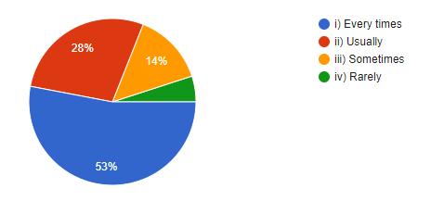
11. Internet facilities available on the campus
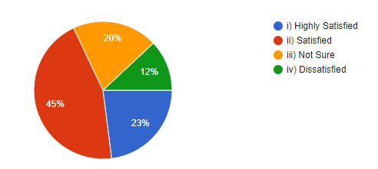
12. Common room in the college building
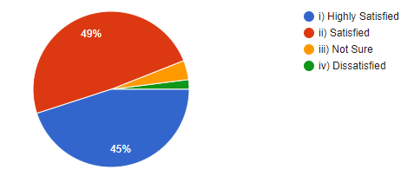
13. Maintance and hygiene of toilet/washroom

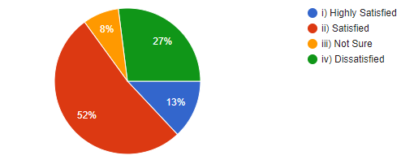
14. Availability of clean drinking water
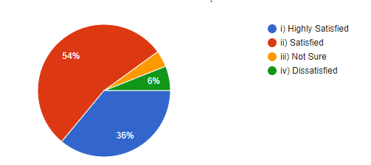
15. Equipment in the laboratories/ Music rooms
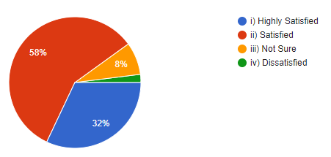
16. Canteen facilities
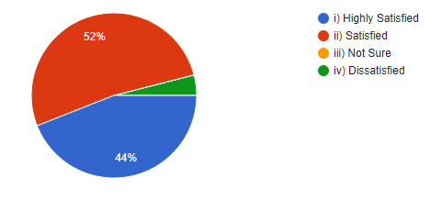
17. Parking facilities
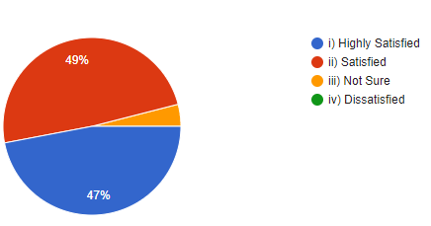
18. Playground
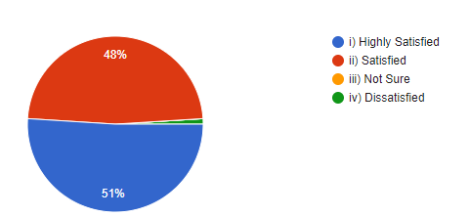
19. Ncc/Nss Room
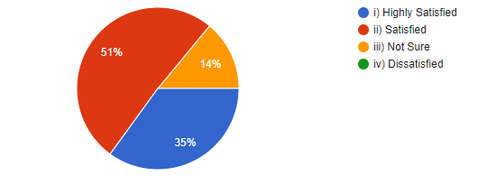
20. Hostel and other accommodation facilities
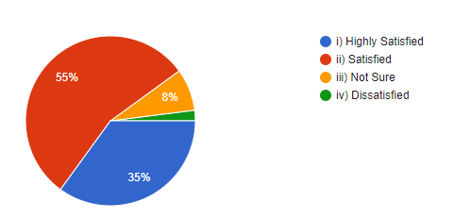
21. Give three observation/ Suggestion to improve the overall teaching-learning experiences in your institution
More smart classrooms
Proper schedule for classes, Library hours should be increased, Arrangement for Safe drinking water
No need of suggestions
Good
Incorporate technology

